Software Testing and Quality Assurance Project Report

Abdullah Almutairi 202101415
Abdulrahman Alharbi 202001916

Table of Contents
- IEEE 829 Test Plan .............................................................. 2
1.1 Test Plan Identifier ...................................................... 2
1.2 Introduction ................................................................. 2
1.3 Test Items ................................................................... 3
1.4 Features to Be Tested .................................................. 3
1.5 Features Not to Be Tested ............................................ 3
1.6 Approach ................................................................. 4
1.7 Item Pass/Fail Criteria .............................................. 4
1.8 Test Deliverables ..................................................... 4
1.9 Testing Tasks ............................................................ 5
1.10 Environmental Needs ................................................ 5
1.11 Responsibilities ....................................................... 6
1.12 Schedule ................................................................. 6
- White-Box Test Case Summary .......................................... 7
- Statement / Code Coverage Report (JaCoCo) .................. 8
- Black-Box Test Cases (EP and BVA) ............................... 9
- JUnit Executions Output ................................................ 10
- Driver Program and Output ........................................... 12
- Conclusion ................................................................. 13
- Appendices ............................................................... 14

1.1 Test Plan Identifier
Testing and QA Project – Java System (Course, Student, GradeCalculator)

1.2 Introduction
This test plan describes the testing approach for three Java classes: Course, Student, and GradeCalculator.
The objective is to verify the correctness of all implemented methods through white-box testing using JUnit and black-box testing using Equivalence Partitioning (EP) and Boundary Value Analysis (BVA).

1.3 Test Items
- Course.java
- Student.java
- GradeCalculator.java

1.4 Features to Be Tested
Course: constructor validation, grade handling, and getGradePoint()
Student: constructor validation, course enrollment, and calculateGPA()
GradeCalculator: validation and logic of calculateLetterGrade()

1.5 Features Not to Be Tested
No GUI elements or external systems are involved.
No file handling or database connectivity to be tested.
1.6 Approach
- White-box testing:
JUnit tests are designed for each method in the three classes to achieve full statement and branch coverage using JaCoCo.
- Black-box testing:
The method calculateLetterGrade() is tested using EP and BVA through a driver program.
- Tools Used:
IntelliJ IDEA, JUnit 4.13.2, and JaCoCo for coverage reporting.
1.7 Item Pass/Fail Criteria
- A test passes if actual output equals expected output.
- A class passes if all unit tests succeed and coverage ≥ 90%.
1.8 Test Deliverables
- Test Plan Report
- JUnit Test Classes
- JaCoCo Code Coverage Report
- Black-box Driver and Console Output

1.9 Testing Tasks
Task | Description | Status
Analyze classes | Identify all methods | Done
Design test cases | Prepare white-box and black-box cases | Done
Implement JUnit tests | Write and execute all tests | Done
Generate coverage report | Run JaCoCo | Done
Implement driver | Test EP/BVA cases | Done
Compile report | Write and format | Done
Prepare presentation | Create slides | Done
1.10 Environmental Needs
Tool | Version | Purpose
IntelliJ IDEA | Latest | Development & testing
Java JDK | 17+ | Execution environment
JUnit | 4.13.2 | Unit testing
JaCoCo | Built-in IntelliJ | Code coverage analysis
1.11 Responsibilities
Team Member | Role
Abdullah Almutairi | White-box testing and coverage analysis
Abdulrahman Alharbi | Black-box testing and driver creation

2. White-Box Test Case Summary
Class | Method | Test Type | Example Input | Expected Output
Course | Constructor | Valid | "Math",3,"A" | Course created with correct fields
Course | getGradePoint | Invalid | "Z" | Returns 0.0
Student | calculateGPA | Mixed grades | A (4.0), B (3.0) | GPA = 3.5
Student | enrollCourse | Null input | null | Course ignored
GradeCalculator | calculateLetterGrade | Boundary | 59 → F / 60 → D | Correct letter grade

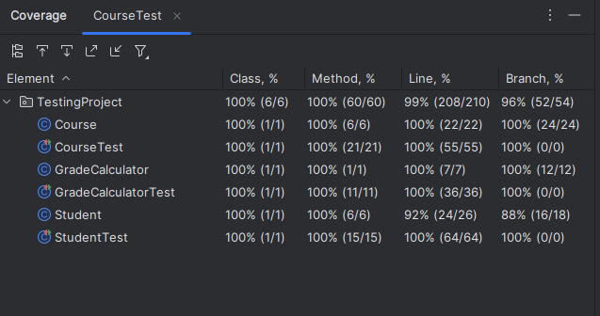
Statement / Code Coverage Report (JaCoCo)

Figure 1: JaCoCo Code Coverage Report

All classes achieved 100% method coverage and 99% line coverage.
Branch coverage exceeded 90% for all classes, confirming thorough testing.

Black-Box Test Cases (EP and BVA)
Equivalence Partitioning (EP)
Input (Score) | Expected Output | Partition
-1 | Invalid | Below valid range
40 | F | 0–59
65 | D | 60–69
75 | C | 70–79
85 | B | 80–89
95 | A | 90–100
101 | Invalid | Above valid range
Boundary Value Analysis (BVA)
Input (Score) | Expected Output | Input (Score) | Expected Output
59 | F | 79 | C
60 | D | 80 | B
69 | D | 89 | B
70 | C | 90 | A

JUnit Executions Output:
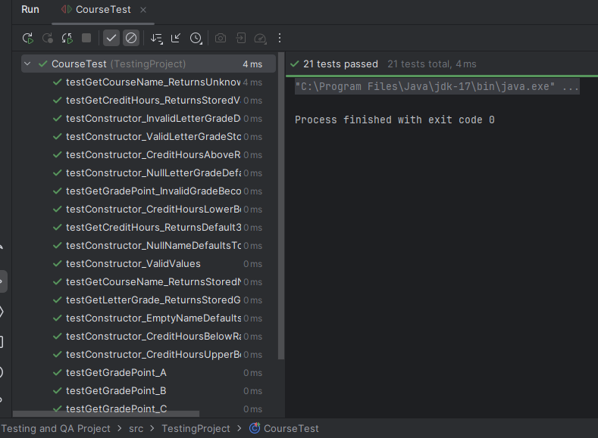
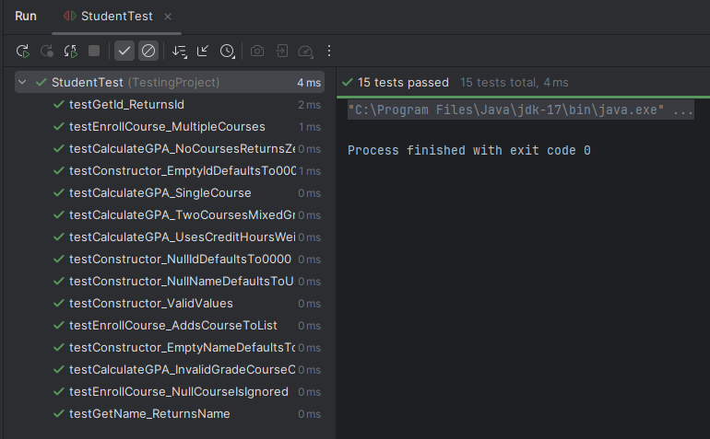
All unit tests for the Course class passed successfully, confirming correct handling of course creation, grade validation, and grade-point calculation for normal, edge, and invalid inputs.
Figure 2: CourseTest JUnit Execution Results
Figure 3: StudentTest JUnit Execution Results
Every test for the Student class executed successfully, verifying proper constructor behavior, course enrollment management, and accurate GPA computation across multiple scenarios.

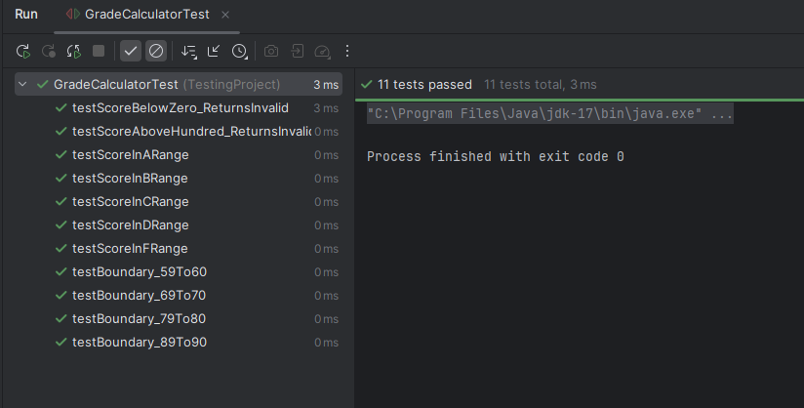
All test cases for the GradeCalculator class passed, demonstrating that calculateLetterGrade() correctly maps numeric scores to letter grades for both equivalence partitions and boundary values.
Figure 4: GradeCalculatorTest JUnit Execution Results

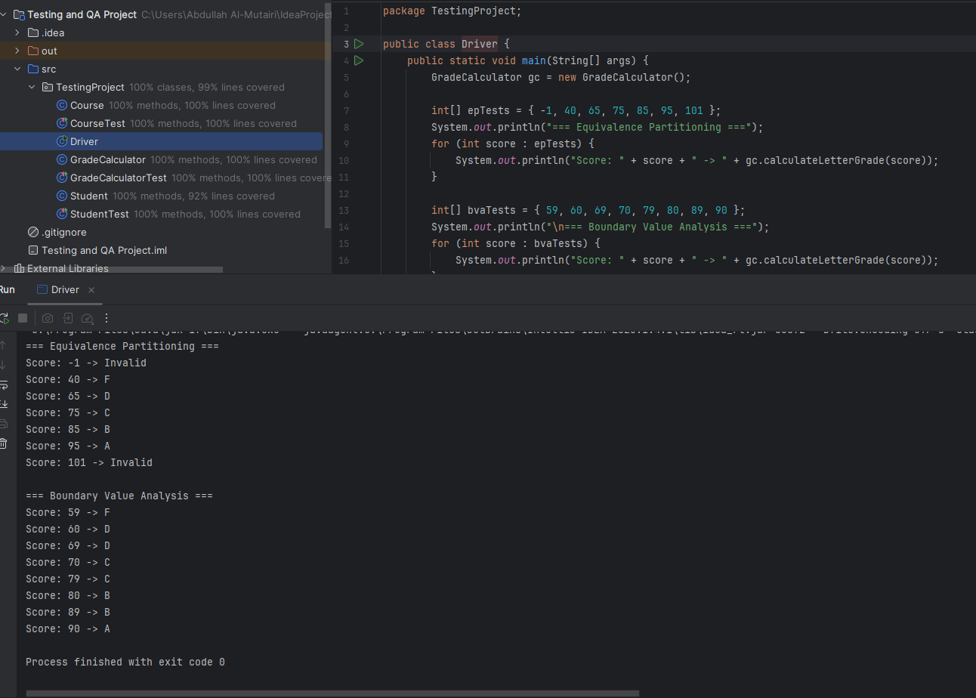
Driver Program and Output:
The driver validates the accuracy of calculateLetterGrade() across all equivalence partitions and boundary values.
The outputs match the expected results, confirming correct and stable behavior.
Figure 5: Driver Output (EP and BVA Results)
package TestingProject;
public class Driver {
public static void main(String[] args) {
GradeCalculator gc = new GradeCalculator();
int[] epTests = { -1, 40, 65, 75, 85, 95, 101 };
System.out.println("=== Equivalence Partitioning ===");
for (int score : epTests) {
System.out.println("Score: " + score + " -> " + gc.calculateLetterGrade(score));
}
int[] bvaTests = { 59, 60, 69, 70, 79, 80, 89, 90 };
System.out.println("\n=== Boundary Value Analysis ===");
for (int score : bvaTests) {
System.out.println("Score: " + score + " -> " + gc.calculateLetterGrade(score));
}
}
}

Conclusion
The project successfully applied both white-box and black-box testing methods.
JUnit and JaCoCo were used to verify correctness and coverage.
All 3 classes achieved 100% method coverage and 99% line coverage.
Black-box testing confirmed that calculateLetterGrade() produces accurate outputs for all valid and invalid input ranges.
All test cases passed successfully, confirming that the software meets its functional requirements.
Overall, the project demonstrates a well-tested, reliable Java implementation and full understanding of structured testing techniques.

